**CONSOLIDATED BUG REPORT FOR ALL THE USER STORIES :**

Total Bugs Found: 5

Overview: During the functional testing of the OrangeHRM website, a total of five bugs were identified. These bugs primarily relate to the incorrect handling of date fields and the display of employee details. The usability of the website is impacted by these issues, as they can lead to incorrect data entry and confusion for the users. Below is a summary of each bug found:

Detailed:

|  |  |
| --- | --- |
| Bug ID number | B__001 |
| Name | Details of employee are correctly displayed |
| Reporter | HARSHIKA SOFAT |
| Submit Date | 06/09/2024, 10:56 AM |
| Summary | The name of the employee should be correctly entered |
| Platform | Window |
| Browser | Chrome |
| Severity | Medium |
| Assigned to | Developer |
| Priority | 2 |

**Description**

The first and last name of some employees contains parts of the code.

**Steps to reproduce**

> go to Orangehrm website

> go to pim section

> In employee list option sort in ascending order

**Expected result**

The name of the employee should be correct with no numbers and codes part

**Actual result**

The name of the employee contains parts of the code

**Screenshot**

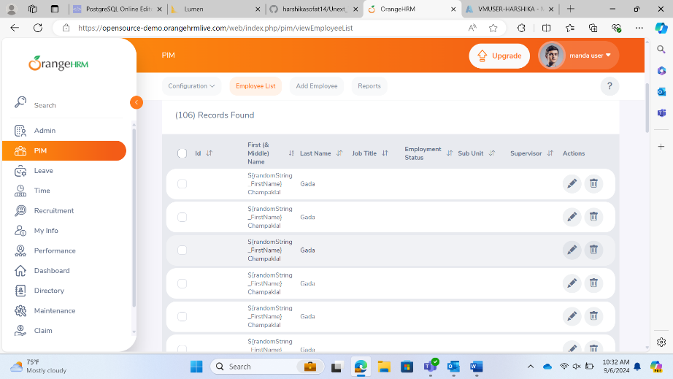

|  |  |
| --- | --- |
| Bug ID number | B__002 |
| Name | Details of employees are correctly displayed |
| Reporter | Puneet |
| Submit Date | 06/09/2024, 11:04 AM |
| Summary | Each employee should have a different employee id |
| Platform | WINDOWS |
| Browser | CHROME |
| Severity | HIGH |
| Assigned to | Developer |
| Priority | 1 |

**Description**

3 employees have the same employee id 0303 but each employee should have different emp id

**Steps to reproduce**

> go to Orangehrm website

> go to pim section

> In employee list option sort in ascending order

>In the end of the page there are 3 employees with same emp id

**Expected result**

Each employee should have different employee id

**Actual result**

3 employees have the same employee id 0303

**Screenshot**

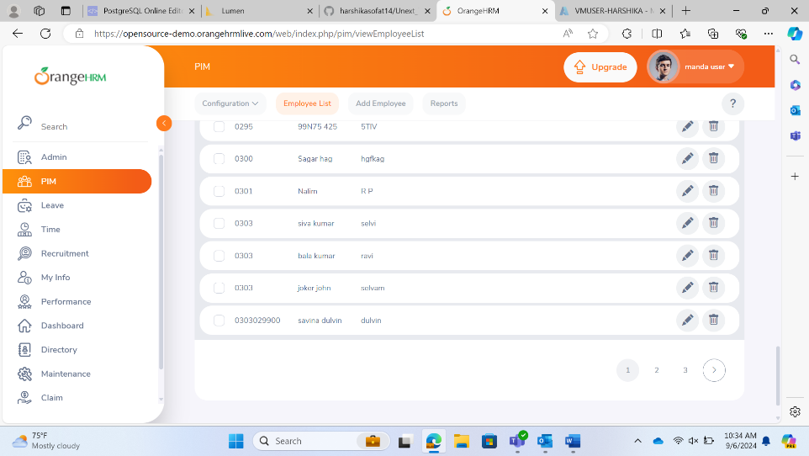

|  |  |
| --- | --- |
| Bug ID number | B__003 |
| Name | Future Date Selection in DOB |
| Reporter | Akshay Rai |
| Submit Date | 06/09/2024, 11:04 AM |
| Summary | The date of birth (DOB) field allows selection of future dates, which is incorrect. |
| Platform | WINDOWS |
| Browser | CHROME |
| Severity | Low |
| Assigned to | Developer |
| Priority | 2 |

Description: In the “My Info” tab, under “Personal Details,” the DOB field allows users to select future dates using the calendar. This should not be possible as a date of birth cannot be in the future.

Steps to reproduce:

* Log in to the OrangeHRM system.
* Navigate to the “My Info” tab.
* Go to the “Personal Details” section.
* Click on the DOB field to open the calendar.
* Select a future date.

Expected result: The calendar should restrict the selection to past and present dates only.

Actual result: The calendar allows the selection of future dates.

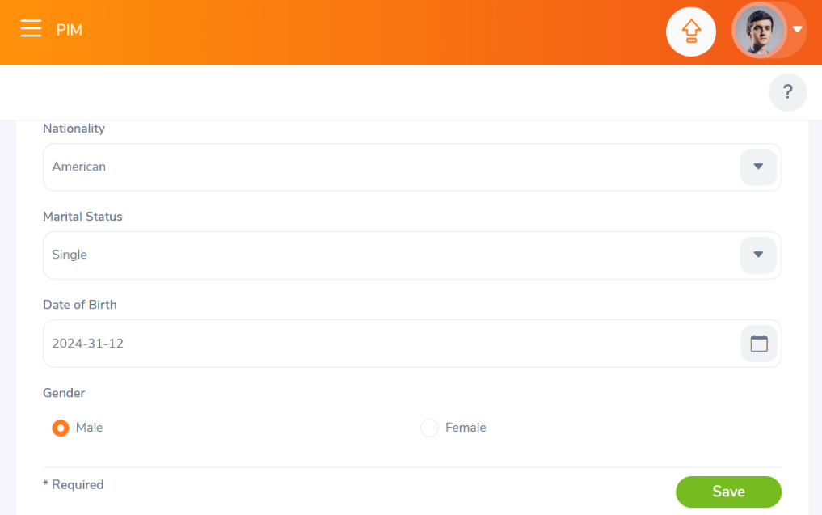

|  |  |
| --- | --- |
| Bug ID number | B__004 |
| Name | Future Date Selection in Qualifications |
| Reporter | Tanisha |
| Submit Date | 06/09/2024, 11:04 AM |
| Summary | The “From” date in the qualifications section allows selection of future dates, which is incorrect. |
| Platform | WINDOWS |
| Browser | CHROME |
| Severity | Medium |
| Assigned to | Developer |
| Priority | 4 |

Description: In the “My Info” tab, under the “Qualifications” section, the “From” date field allows users to select future dates. This should not be possible as qualifications cannot start in the future.

Steps to reproduce:

* Log in to the OrangeHRM system.
* Navigate to the “My Info” tab.
* Go to the “Qualifications” section.
* Click on the “From” date field to open the calendar.
* Select a future date.

Expected result: The calendar should restrict the selection to past and present dates only.

Actual result: The calendar allows the selection of future dates.

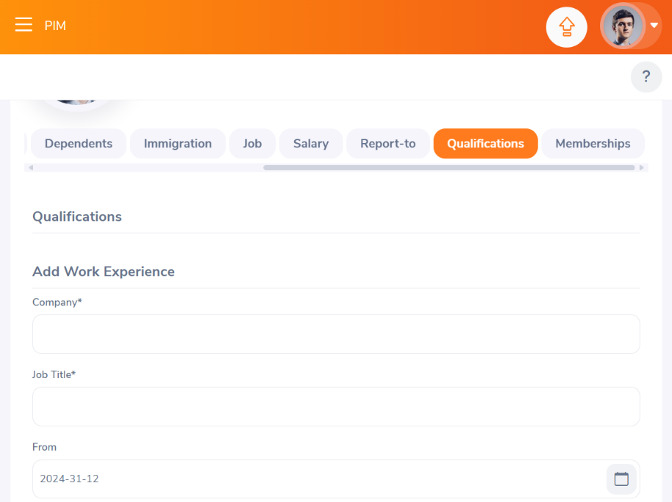

|  |  |
| --- | --- |
| Bug ID number | B__005 |
| Name | Past Date Selection in Immigration Expiry Date |
| Reporter | Sushma |
| Submit Date | 06/09/2024, 11:04 AM |
| Summary | The expiry date field in the immigration section allows selection of past dates, which is incorrect. |
| Platform | WINDOWS |
| Browser | CHROME |
| Severity | Medium |
| Assigned to | Developer |
| Priority | 5 |

Description: In the “My Info” tab, under the “Immigration” section, the expiry date field allows users to select past dates using the calendar. This should not be possible as an expiry date cannot be in the past.

Steps to reproduce:

* Log in to the OrangeHRM system.
* Navigate to the “My Info” tab.
* Go to the “Immigration” section.
* Click on the expiry date field to open the calendar.
* Select a past date.

Expected result: The calendar should restrict the selection to present and future dates only.

Actual result: The calendar allows the selection of past dates.

